**ASSIGNMENT 1**

**GIT COMMANDS**

**SUBMIT VIA SCREENSHOT OF YOUR CMD**

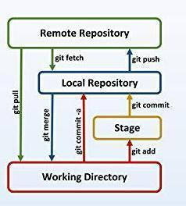

Q1. Q. Create a local git repository in your local machine first.

Commit the initial code

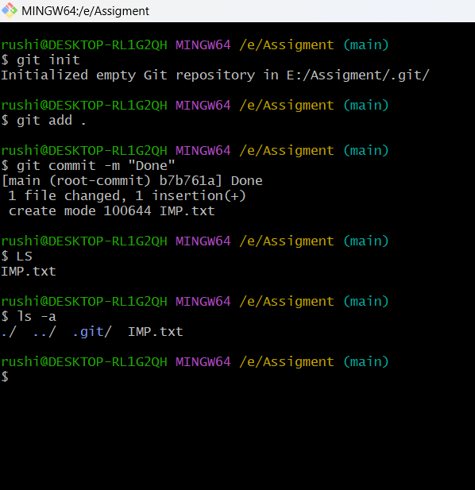

Q2. Q. Update the code on the remote server . Also perform some changes on remote n reflect the same on local.[push/pull operations

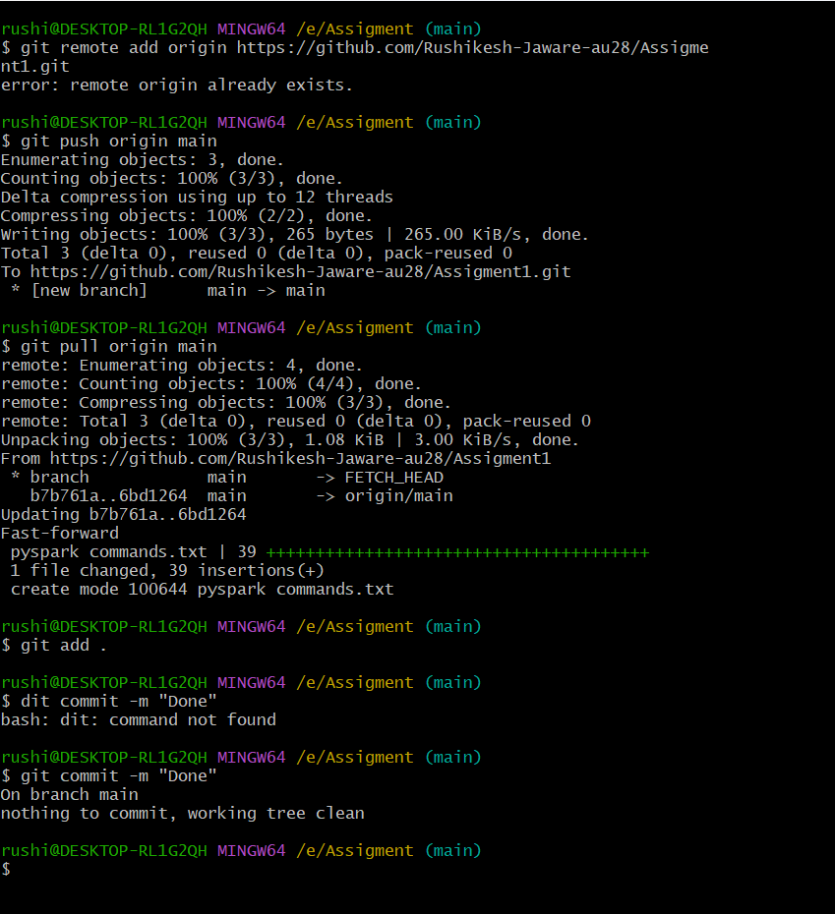

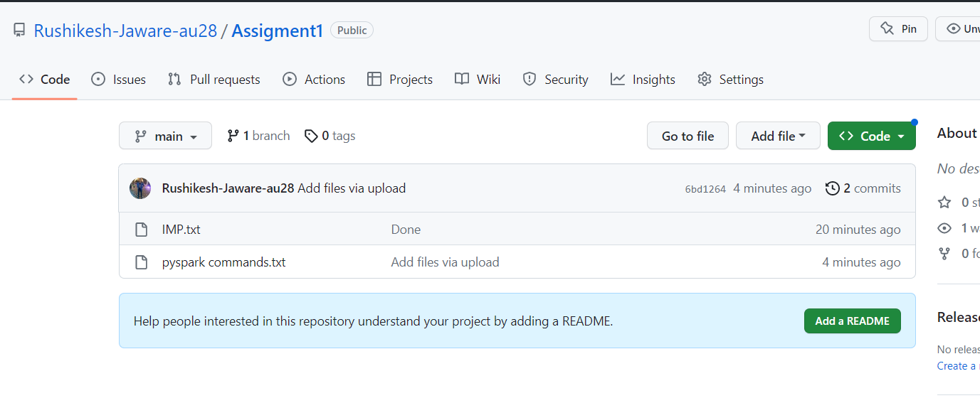

Q3. Q. Create g1 branch on the github..................Add 1 txt file .................Raise a pull request on remote from g1 towards main........................... and merge without conflicts. [REMOTE MERGING]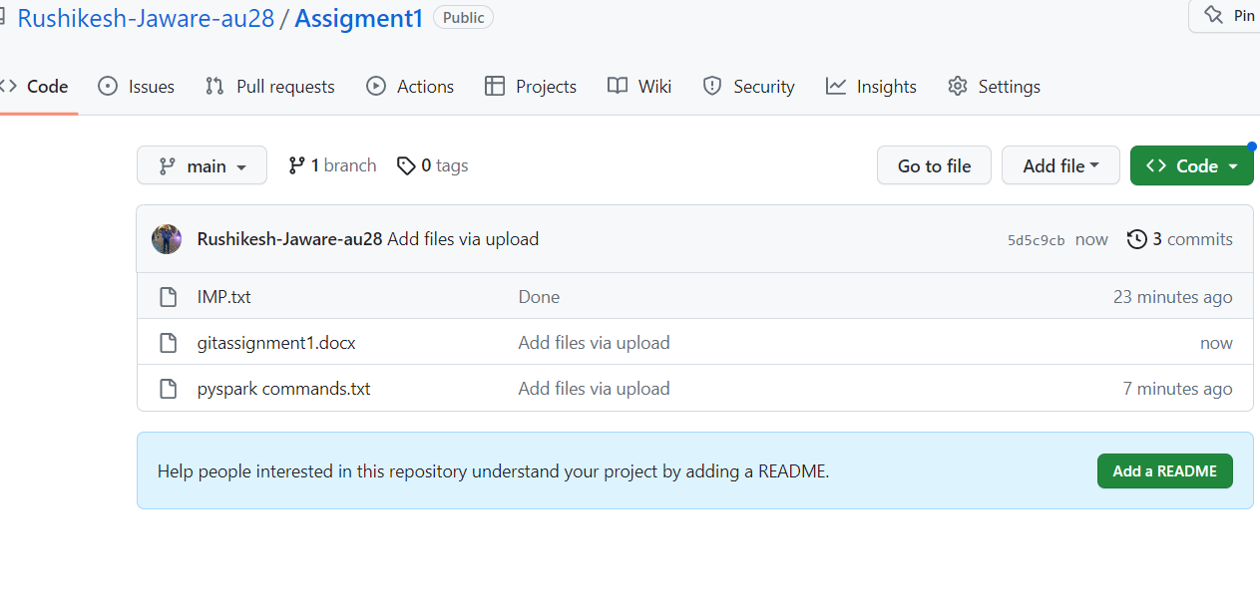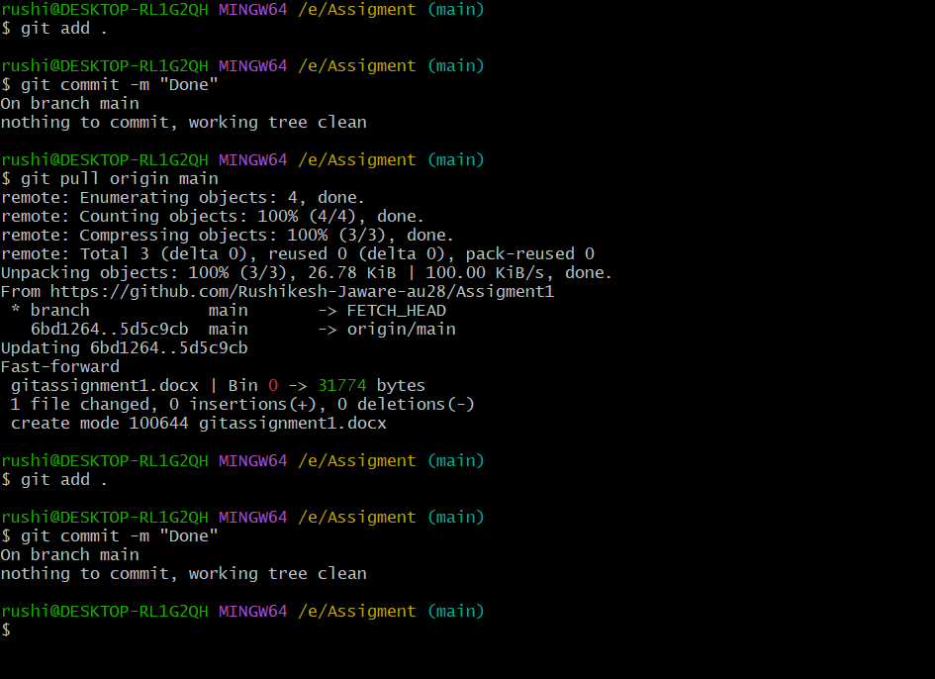

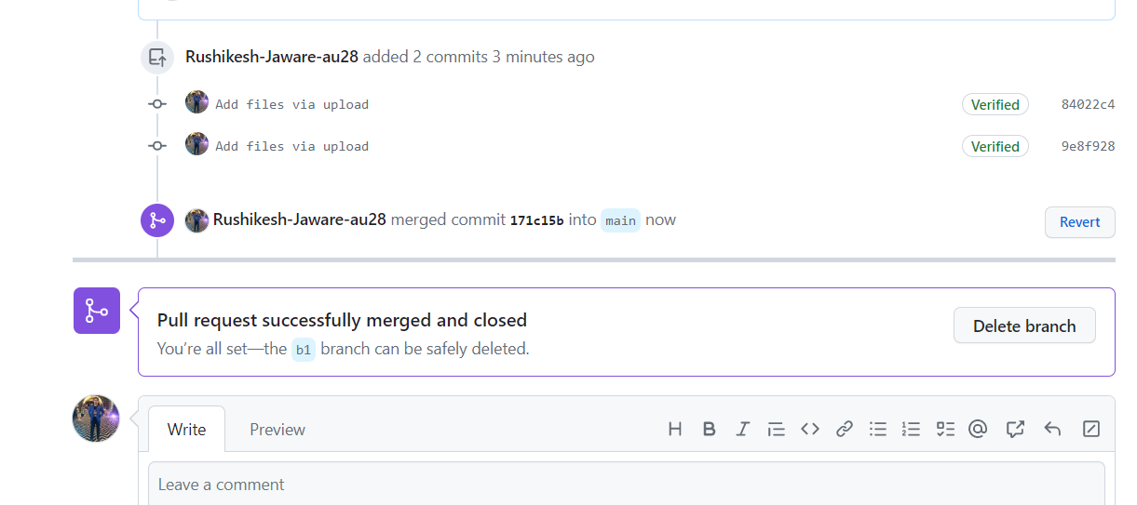

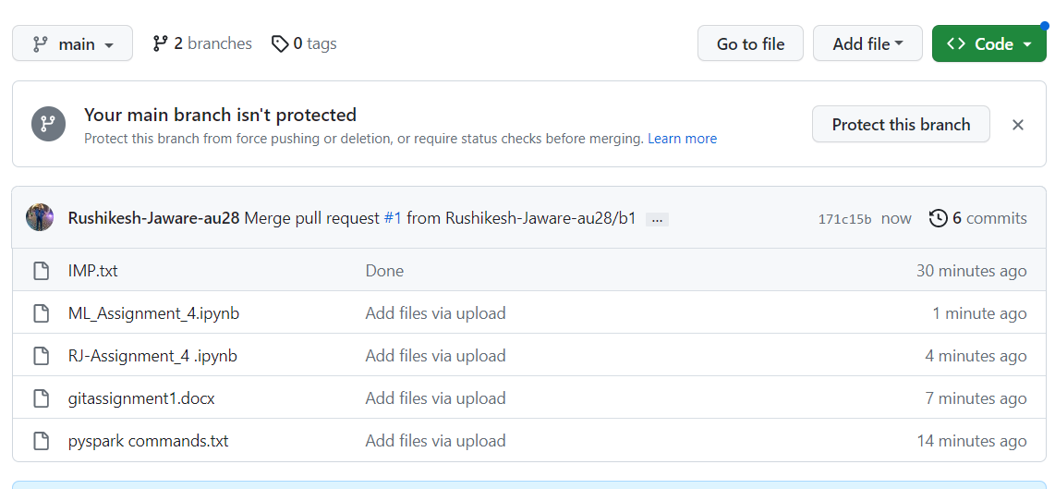

Q4.1) Local git: Use git commands too Get the updated files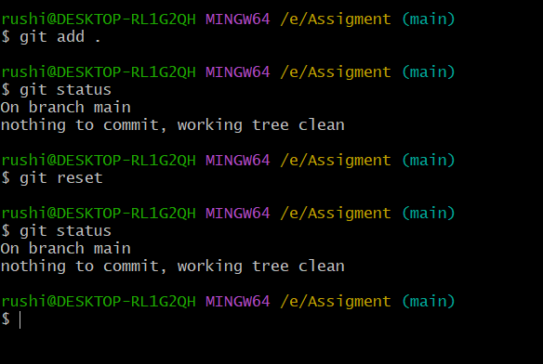

Q4.2 o Perform reset/Revert

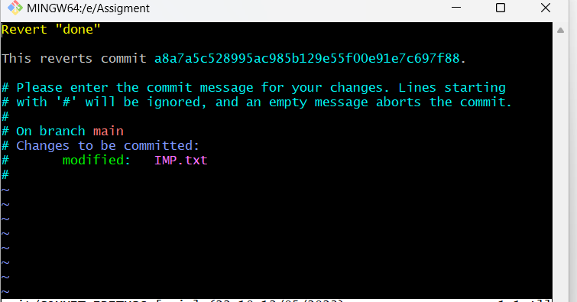

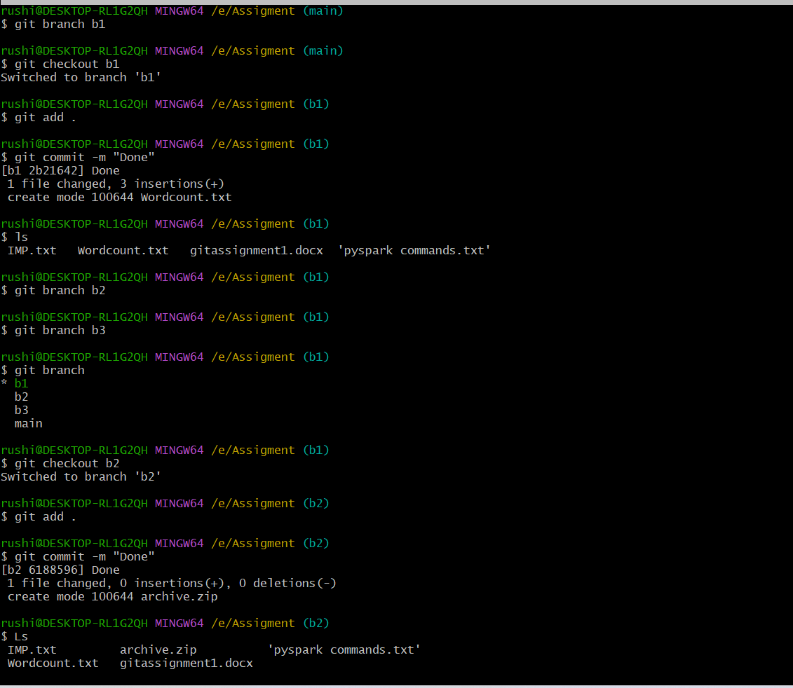

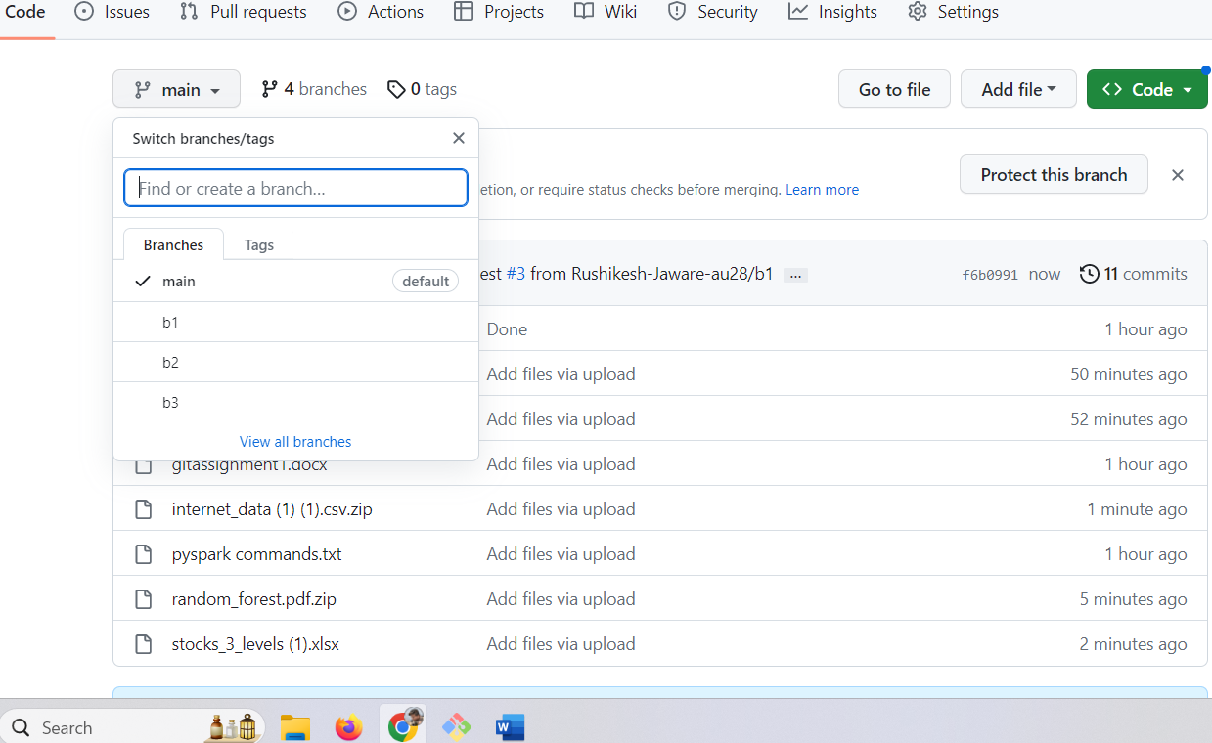

Demonstrate diff between local branches

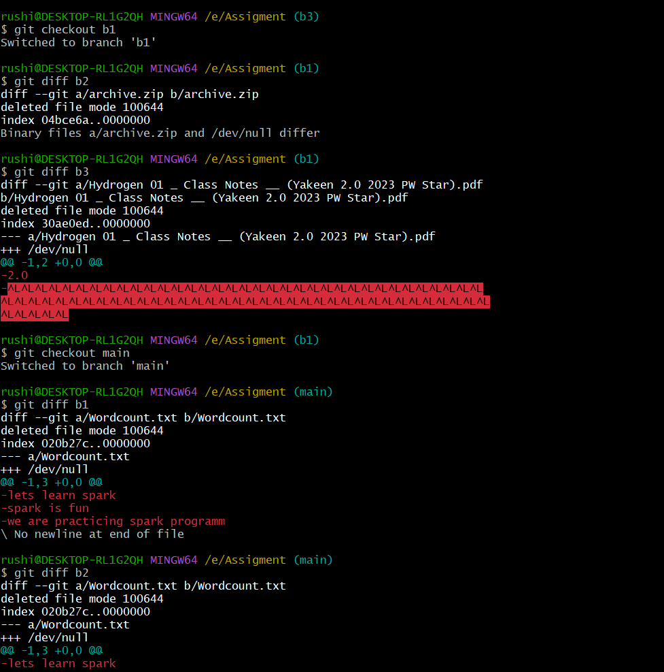

Perform LOCAL merging operation and after that delete the unnecessary ones locally as well as remote

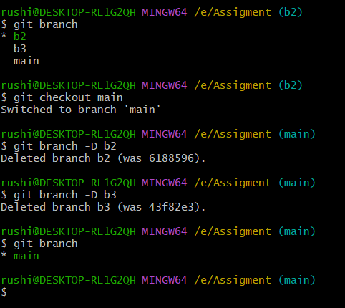

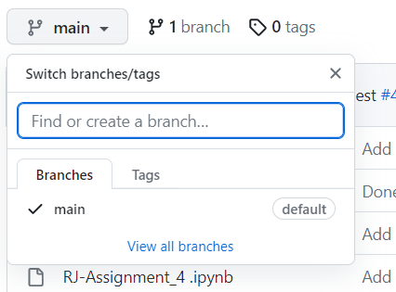

Perform fork operations on your repository as well.

